Send them a Letter
This advertisement was part of Australia Post’s campaign to promote personal letter writing as an important mode of human communication.
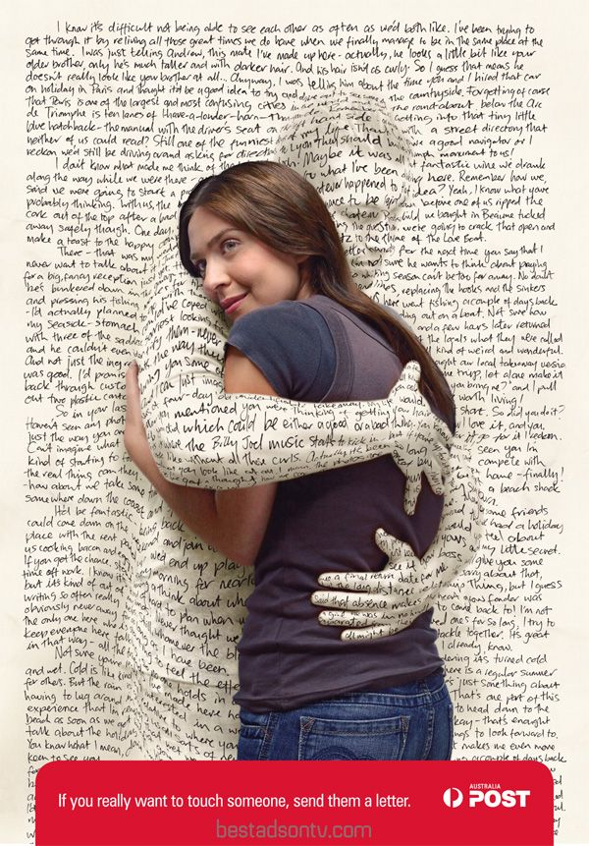
Reading for meaning:
- What is the message of this advertisement? Refer to both the words and picture in your answer.
- Do you think this is an effective advertisement?
- Some people feel that it is a shame that digital communication is replacing the traditional post. Do you agree? Give your reasons.

Writers Workshop:
Speech:
This advertisement deals with changes in how we communicate nowadays. Write a speech about changes in the modern world. In your speech you may celebrate these changes or argue that society has changed for the worst.

OR

Personal Letter:
Write a genuine personal letter to somebody you know. In your letter, describe anything of interest in your life at the moment. Enquire about the other person.

Listen to the song by Arcade Fire – ‘We Used to Wait’

