My Muse is Not a Horse
Nick Cave
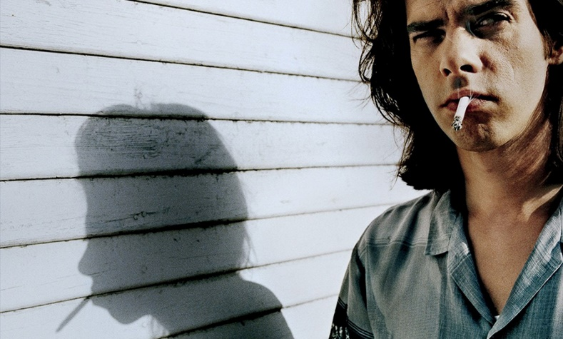
Nick cave is an Australian singer, songwriter, musician, author and composer. He is well known as the frontman for the band Nick Cave and the Bad Seeds and The Birthday Party.
In 1996, Nick Cave’s ninth album Murder Ballads became hugely popular, reaching a wider audience than any of his previous records. Nick cave describes being ‘catapulted into the role of superstardom’. Following his new popularity, MTV nominated him for the award of Best Male Artist. This is the letter Nick Cave wrote in response.
21 Oct 96
To all those at MTV,
I would like to start by thanking you all for the support you have given me over recent years and I am both grateful and flattered by the nominations that I have received for Best Male Artist. The air play given to both the Kylie Minogue and P. J. Harvey duets from my latest album Murder Ballads has not gone unnoticed and has been greatly appreciated. So again my sincere thanks.
Having said that, I feel that it’s necessary for me to request that my nomination for best male artist be withdrawn and furthermore any awards or nominations for such awards that may arise in later years be presented to those who feel more comfortable with the competitive nature of these award ceremonies. I myself, do not. I have always been of the opinion that my music is unique and individual and exists beyond the realms inhabited by those who would reduce things to mere measuring. I am in competition with no-one.
My relationship with my muse is a delicate one at the best of times and I feel that it is my duty to protect her from influences that may offend her fragile nature.
She comes to me with the gift of song and in return I treat her with the respect I feel she deserves — in this case this means not subjecting her to the indignities of judgement and competition. My muse is not a horse and I am in no horse race and if indeed she was, still I would not harness her to this tumbrel — this bloody cart of severed heads and glittering prizes. My muse may spook! May bolt! May abandon me completely!
So once again, to the people at MTV, I appreciate the zeal and energy that was put behind my last record, I truly do and say thank you and again I say thank you but no…no thank you.
Yours sincerely,
Nick Cave

Reading for meaning:
- Using your own words, explain why Nick Cave declined the MTCV nomination.
- Do you agree with this stance that Cave has taken?
- Explain the phrase , “My muse is not a horse and I am in no horse race”.
- How do you imagine the organisers of the awards at MTV felt about this letter of rejection?
Language Lab:
- Do you agree that Nick Cave’s letter is full of rich, poetic imagery? You may wish to explore his use of metaphor and personification.
- (a) Giving examples from the letter, describe the tone Cave adopts in this letter.
- Why do you think he adopts this tone?
Writers Workshop:
Letter of Reply: Imagine you work for MTV. Your job is to draft a response to Nick Cave’s letter. Write the letter that you would send.

