Doolin hotel manager Donal Minihane’s magnificent response to a bad review on TripAdvisor
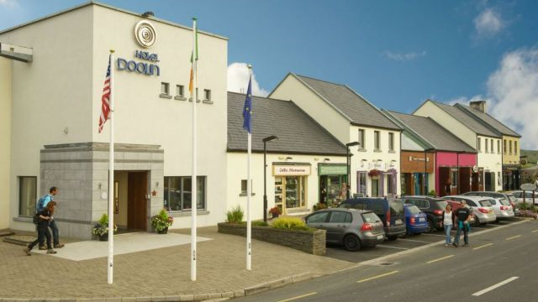
The correspondence below was written in response to a harsh review received on tripadvisor.ie. the original review gave the Hotel Doolin in County Clare a one-star rating, referencing the lying staff, “worst wifi ever” and the “bunch of grumpy old men” who worked in the restaurant.
Thank you for staying with us at Hotel Doolin on your recent trip to Ireland and for posting your feedback. We were very disappointed with the content of your review.
However, after investigating the particulars of your stay in detail with all team members I was even more disappointed to learn that the content of the review was not an accurate reflection of what actually happened.
From the title of your review, other readers would think that you inadvertently stumbled into Hitchcock's Jamaica Inn and that Hotel Doolin was full of brigands and cutthroats, that our staff wear eye patches and pantaloons and are hiding behind the pillars in the lobby, cutlass clenched between our teeth, waiting to jump out and pillage passerbys.

You say the hotel is deceitful and dishonest and that one of our staff members, Emma, is a liar when, in fact, it is your good self that is being liberal with the truth. Emma did make a mistake on check-in with the rate, this was spotted the following morning by one of our more senior receptionists and was rectified before you checked out so that you never paid €240 as you stated above.
Also, the duty manager met you the following morning, apologised for the mistake and gave you a further reduction on your rate.
We are 100% certain that Emma made a genuine mistake, as sometimes people do, and we feel it is very unfair and irresponsible of you to call her a liar and dishonest on a public forum.
I'm sensing a lot of anger in the review above and I know that you probably didn't mean to let loose all that anger on us. Hey, sometimes people just need to vent. Sometimes at night when I come home from a long day’s work at the hotel, I check to see if everyone is in bed and then I go out into the field at the back of my house and scream into the darkness. I let it all out, like a wolf on a moonlit mountain.
I feel better after that and nobody gets hurt. I'm not saying howling into the night like a wolf will work for you, I don’t know your circumstances, you may have neighbours that’ll think it is weird, but there are other ways of channelling rage that don't have to involve Hotel Doolin and slandering Emma.
With regards the Wi-Fi, yes, the Wi-Fi in the west of Ireland is the worst in Europe, there is nothing we can do about this for the moment, although I think we are getting high-speed broadband in the area pretty soon. in the meantime, to anybody else reading this review. DO NOT COME TO DOOLIN IF WI-FI IS MORE IMPORTANT TO YOU THAN HUMAN INTERACTION, YOU WILL BE DISAPPOINTED.
There are three men over the age of forty working in the hotel. Only one of them was working on the night you stayed, so we didn’t know how to deal with the ‘grumpy old men’ in your review, until my assistant manager came up with the only viable solution.
We’ve decided to execute all three of these men to ensure that no other guests will have to endure the horrific ordeal you went through that evening in the bar.
Paul, Martin and Luis will be blindfolded and shot in the back of the head at Fitz’s cross after mass this Sunday. There will be trad music, cocktail sausages and face-painting for the kids and I can organise a pair of complimentary tickets for you if you wish to attend. I know this will not make up for what happened to you but we hope it will go some way towards showing you that we take your feedback seriously.
You see, even though you hurt us deeply with your review, we'd still like to be friends, we'd love if you afforded us the opportunity to change your opinion of us and hope that you will return to Doolin someday.
In fact, each year on the 30th February we have a party for our valued past customers who think we are liars, we all hold hands and dance around a campfire and sing songs that help us forget about the past and look with hope towards the future. We'd love if you could make it(that lying cheating ruffian Emma won’t be there, we promise).

Reading for Meaning:
- (a) Describe the tone used in this piece above.
(b) Why do you think the author used this type of tone?
2. Explain how the humour used in this correspondence could be described as ‘tongue-in-cheek’.
3. Do you think this was an effective way for the hotel to deal with the negative review?
4. Websites often give members of the public the opportunity to publish unedited reviews of products and services. In your view, what are the positives and negatives of this?

Writers workshop:
Review: Donal Minihane’s letter was written in response to a negative review. Write a positive review, to be published online, of something you have purchased or a place you have visited.

