The Mirror
Joseph moved furtively along the corridors of his grandmother’s house. The whole building was somewhat antiquated, with quaint trinkets and dusty ornaments littering every vacant shelf. However, the upstairs was now a wild, forsaken land: untouched for decades. Ever since his grandmother was incapacitated by a major injury to her legs it was declared off limits.
Nobody can say what it was the possessed Joseph to embark up those stairs. Perhaps it was rebelliousness, curiosity, or even simple boredom. Either way, he had took it upon himself to contravene his grandmother’s rules by entering a world he knew was strictly out of bounds.
Floorboards creaked and groaned as Joseph crept along them. Compared to downstairs, which was so warm and homely, the upstairs reeked of negligence and had an almost unwelcoming atmosphere. The air was still and thick, as if it might obstruct your airways if you breathed it in for too long.
After a minute or two of idle observation, something caught his eye.
The mirror.
Gravely, silently, Joseph approached the cracked, crazed surface of the mirror. There was something unusual about his reflection. Something he didn’t recognise. The features of his face were somehow unfamiliar, twisting and contorting the longer he beheld them. Despite this, there was nothing he could do to look away. Transfixed by the image in front of him, Joseph stood anchored to the spot, remaining, the whole time, inexplicably silent.
“Joseph! Your dinner is ready!” rang his grandmother’s voice through the house.
No response.
For ten more minutes Joseph’s grandmother would call after him. Soon, concern turned to panic. Emergency services were called. The house was searched.
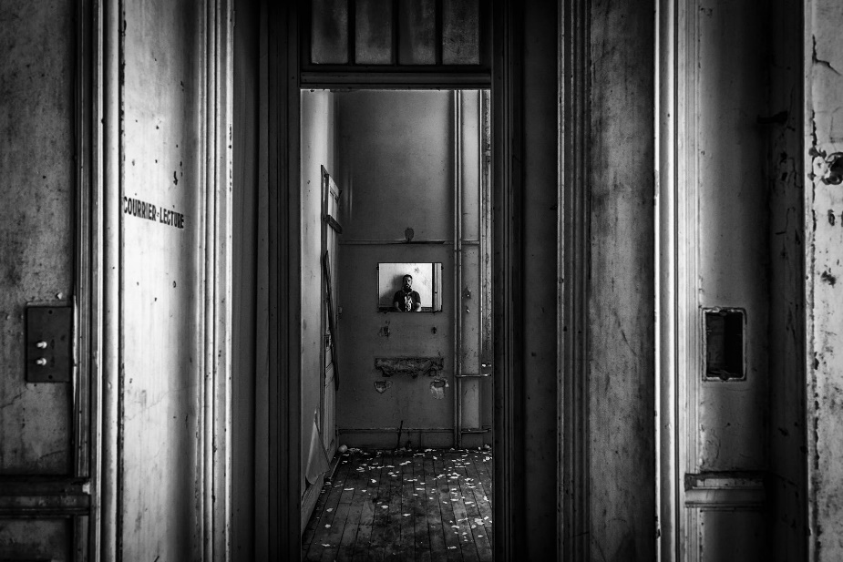
To this day, nobody knows what happened to Joseph Stephenson.
- Highlight all the impressive vocabulary in this story
- Underline any words you are unsure of and look these up in the dictionary. Record the definitions in your book

