Hamlet
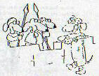 | 1. The play begins with guards and a young courtier nervously assembled on the castle battlements. The reason for their vigil appears - a ghost. In fact, it is the ghost of the dead king, Hamlet, but will not speak to them.
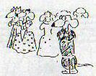 | 2. Prince Hamlet, the ghost's son, is in the court below, ostentatiously wearing mourning black amid everyone else's bright colours. (The court is celebrating the marriage of his mother, Gertrude, to his uncle, Claudius, barely a month after King Hamlet's death.)
 | 3. Hamlet is angry, humiliated, and physically revolted by the though of the marriage. He makes unkind comments and speaks unconvincingly of suicide: he is feeling very sorry for himself.
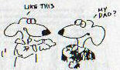 | 4. The young man on the battlements, Hamlet's good friend Horatio, tells the Prince what he and the men have seen. Since unquiet ghosts often foretell disasters, they decide that they had better find out what the ghost means.
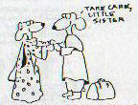 | 5. Laertes, a contemporary of Hamlet's, is going back to university. He says farewell to his sister Ophelia and warns her of her fondness for Hamlet. The Prince, he says, cannot marry for love; even if he loves Ophelia, she had better be careful.
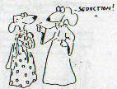 | 6. Laertes is sent off by his father, Polonius, with an earful of advice. Polonius talks to Ophelia about Hamlet, but his interpretation is that Hamlet will say anything to seduce a girl. (Polonius would.) He forbids Ophelia to see Hamlet and tells her to send back all the gifts.
 | 7. Hamlet, Horatio, and the guards wait on the windy walls of Elsinore. All are nervous - especially Hamlet. The ghost appears and beckons Hamlet to the most dangerous part of the walls. Though the others try to prevent him (the ghost may be a demon), Hamlet follows.
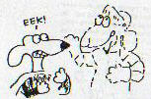 | 8. The ghost tells Hamlet the news that he didn't want to hear: Uncle Claudius murdered Hamlet's father, King Hamlet, and seduced Gertrude into marrying him. Hamlet must now avenge for his father's murder, but leave his mother to heaven. The ghost vanishes.
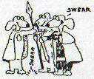 | 9. Hamlet realizes the news puts him and his friends in danger. He swears them to secrecy (with the help of the ghost) but he really doesn't want to be the avenger of his father. He doesn't know what to do.
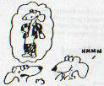 | 10. Ophelia reports to her father, Polonius: she is very disturbed by Hamlet's strange behaviour (as are Gertrude and Claudius). Hamlet, his clothing all messy, has come into her room and just stared at her.
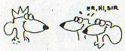 | 11. Claudius has summoned two of Hamlet's university friends. Rosencrantz and Guildenstern, to spy on Hamlet. They agree to this quite willingly (although they don't have much of a choice: Claudius is the king).
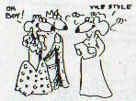 | 12. Polonius bustles in, saying he's found the cause of Hamlet's madness - love. He whips out one of Ophelia's letters from Hamlet and reads it before the entire court (sensitive, isn't he??). He criticizes its style and says he'll set up a meeting others can watch.
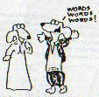 | 13. The rest of the court clears out as Hamlet approaches. Polonius tries to get him to commit himself about Ophelia, but Hamlet weaves a web of half-mad words that confounds the old man.
 | 14. When Rosencrantz and Guildenstern try to pump Hamlet for information, the result is much the same. Hamlet finds out they are working for Claudius and warns them they're playing a dangerous game.
 | 15. Hamlet is diverted by the arrival of travelling players. He begins a speech he liked, and the players' leader finishes it for him, speaking so passionately that he changes colour and cries. Hamlet engages the group to play "The Mouse-trap" before the court tomorrow night.
 | 16. Alone, Hamlet berates himself. If the player can work up that much emotion about a literary character, why can't Hamlet do something about his father's murder? The play will test Claudius: if he reacts, he's guilty (the play is similar to the murder); if he doesn't, the ghost is an evil spirit.
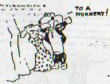 | 17. Remember Polonius's plan for Ophelia? He plants her in the hall to meet Hamlet while he and Claudius eavesdrop from behind tapestries. Hamlet realizes this is a setup. He tells Ophelia to get to a nunnery (ie. to a safe place) before the court corrupts her, and threatens Claudius.
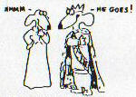 | 18. Angered at Hamlet's implied threat. Claudius decides to send Hamlet away to England. Polonius suggest that Gertrude might be able to reach where Ophelia failed.
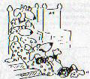 | 19. Hamlet tells the players how to act, then, as the court assembles to hear the play, he is very rude to Ophelia. Since she hasn't left, he assumes she is being used willingly. Poor Ophelia is even more distressed and confused by his behaviour.
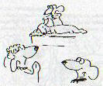 | 20. The play begins and the players act out a king being murdered (just he way King Hamlet was) by a trusted advisor, who then woos and wins the widowed queen. Gertrude watches calmly.
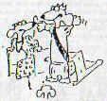 | 21. But not Claudius! He gets up and storms out before the play is finished. Now he knows that Hamlet knows that his father's death was murder, how it was done, and "who done it." Suddenly Hamlet is a very real danger to Claudius.
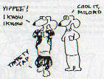 | 22. Hamlet is delighted at how his plan worked. He now knows that Claudius is guilty and the ghost was real. Again he warns Rosencrantz and Guildenstern that they can't manipulate him. Although he sees through Polonius fawning, he agrees to visit Gertrude.
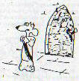 | 23. Now that he knows he's in danger, Claudius tries to pray. He won't give up his ill-gotten prizes, so he just kneels and recites formulas of prayer. Hamlet sees him, alone and unguarded, but believes that to kill Claudius while he's praying would send him to heaven. Hamlet tiptoes on by.
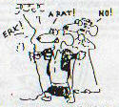 | 24. Polonius has hidden behind the big tapestry in Gertrude's bedroom. When Hamlet begins to get angry at Gertrude, Polonius calls for help. Think the voice comes from Claudius, Hamlet stabs right through the tapestry and kills Polonius. Gertrude is horrified.
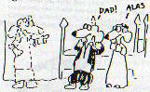 | 25. As Hamlet tries to convince Gertrude to leave Claudius (without telling her that her present husband murdered her former husband). King Hamlet's ghost appears to protect Gertrude. She cannot see it, and as Hamlet talks to "nothing", she becomes convinced he really is mad.
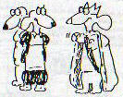 | 26. Hamlet's murder of Polonius is discovered, and Hamlet is arrested. Hamlet is rude to Claudius, but Claudius won't react. (He doesn't want to put Hamlet on trial: Hamlet knows too much.) Instead, Claudius breaks his own land's laws by sending Hamlet away to England.
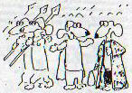 | 27. On his way, Hamlet meets a captain in Fortinbras's army. Fortinbras, the Prince of Norway, is held up as the ideal, but Hamlet wonders about the war he's waging for a scrap of land that can't bury the bodies of the men who will die fighting for it. If that's honour, why, Hamlet wonders, does he worry about killing one man?
 | 28. Back at the castle, Ophelia has gone mad. The man she loves has rejected her privately and publicly and killed her father. She wanders about the castle, singing songs about dead men and faithless lovers.
 | 29. Laertes bursts into the castle at the head of a mob. Claudius, playing the king, dares them to touch his sacred person. Laertes dismisses his followers and demands to know what happened to his father and why Hamlet has not been punished.
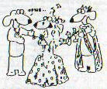 | 30. As Claudius says he's not responsible, Ophelia comes back in. Laertes is horrified at what has happened to his beloved sister and vows vengeance. Like Hamlet, he is now a young man with a mission.
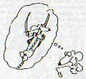 | 31. Sailors have brought Horatio a letter. In it he finds that Hamlet was captured by pirates when he led the attack on them. (To die in battle would be the easy way out for Hamlet, the reluctant avenger.) Hamlet is on his way home to Denmark.
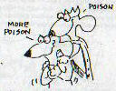 | 32. Claudius is working on Laertes, turning Laertes's geniune vengeance into a tool of a corrupt king. Laertes agrees to Claudius's scheme of a duel with trick swords and poisoned wine, and suggests poisoning the tip of his sword as well. Claudius has corrupted him.
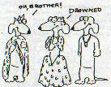 | 33. Laertes and Claudius have received Hamlet's letter saying he's returning and vow to act quickly. Gertrude brings news of Ophelia's death - suicide by drowning. She is upset, Laertes is devastated, but Claudius is only annoyed at the inconvenience.
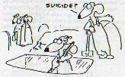 | 34. Two gravediggers work on Ophelia's grave and discuss the case. Suicides weren't buried in churchyards, and both these men know that if Ophelia hadn't been who she was, she wouldn't be buried here. (Claudius is now bending church law.) Hamlet and Horatio approach.
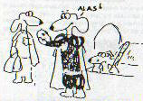 | 35. Hamlet plays with the idea of death, which is never far from his mind. He speculates on death in general, but then the gravedigger makes it personal by handing him the skull of a childhood friend, Yorick the jester. Hamlet has scarcely recovered himself when a funeral approaches.
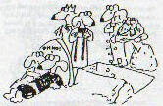 | 36. Hamlet does not know Ophelia is dead, but as he spies on the funeral the awful truth dawns on him. Laertes, Gertrude, and Claudius all mourn Ophelia in her shabby little funeral.
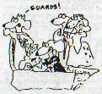 | 37. When Laertes, wild with grief, leaps into Ophelia's grave, Hamlet can stand being hidden no longer. He comes out and gets into the an unfortunate fight with Laertes about who loved Ophelia most.
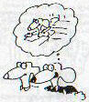 | 38. Later, a much calmer Hamlet tells Horatio what he's done. He has stolen the letter his escorts (Rosencrantz and Guildenstern) were carrying, which commanded the King of England to execute Hamlet immediately, and replaced it with a letter that says "execute bearers."
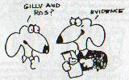 | 39. Horatio is aghast that Hamlet would order the death of his university chums. Hamlet says they were willing tools of Claudius and he is not concerned. Besides, now he has hard evidence (the letter) of Claudius's plotting to show the court, the courts, and Gertrude.
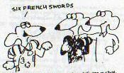 | 40. Osric, a foppish young courtier, delivers a challenge. The king has bet six Arab horses against six french swords that Hamlet can beat Laertes in a duel. After playing with Osric a bit, Hamlet accepts the challenge.
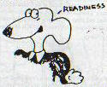 | 41. Horatio is worried and fears another plot by Claudius. Hamlet says the key to life is to live it as though every day would be your last and that he is ready for what is to come.
 | 42. Before the duel begins, Claudius drops a pearl coated with poison into a goblet of wine as a toast to Hamlet. Hamlet apologizes to Laertes for his behaviour, saying they're in similar circumstances. Laertes begins to have second thoughts.
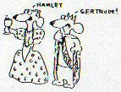 | 43. Hamlet wins the first two touches of the sword. Gertrude is so pleased at his performance and apparent sanity that she takes the poisoned cup and drinks a toast to him. Claudius doesn't stop her (because he'd have to explain why).
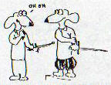 | 44. Laertes, shocked that the king would let Gertrude (whom he loved so much) drink the poisoned wine, continues the duel. He wounds Hamlet with his poisoned sword, but in the fray the swords are exchanged and he is wounded with it too.
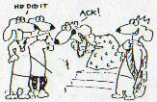 | 45. Suddenly Gertrude cries out that the wine was poisoned. Claudius tries to deny it, but Laertes, seeing him for what he really is, tells the whole plot - poisoned wine, poisoned swords, and all.
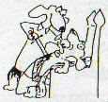 | 46. Hamlet turns on Claudius, forces the last of the poisoned wine down his throat and stabs him with the venomed sword for good measure.
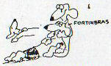 | 47. Realizing he is dying, Hamlet forgives Laertes (who, because he has been stabbed closer to the heart, dies first). He gives the kingdom to Fortinbras. Then he dies in Horatio's arms.
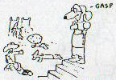 | 48. Fortinbras returns from his Polish war at that moment and is horrified by all the dead bodies in the court. He is sorry Hamlet is dead, for he feels Hamlet would have ruled well. He takes over and orders the honour of a state funeral for the dead prince.

The End

