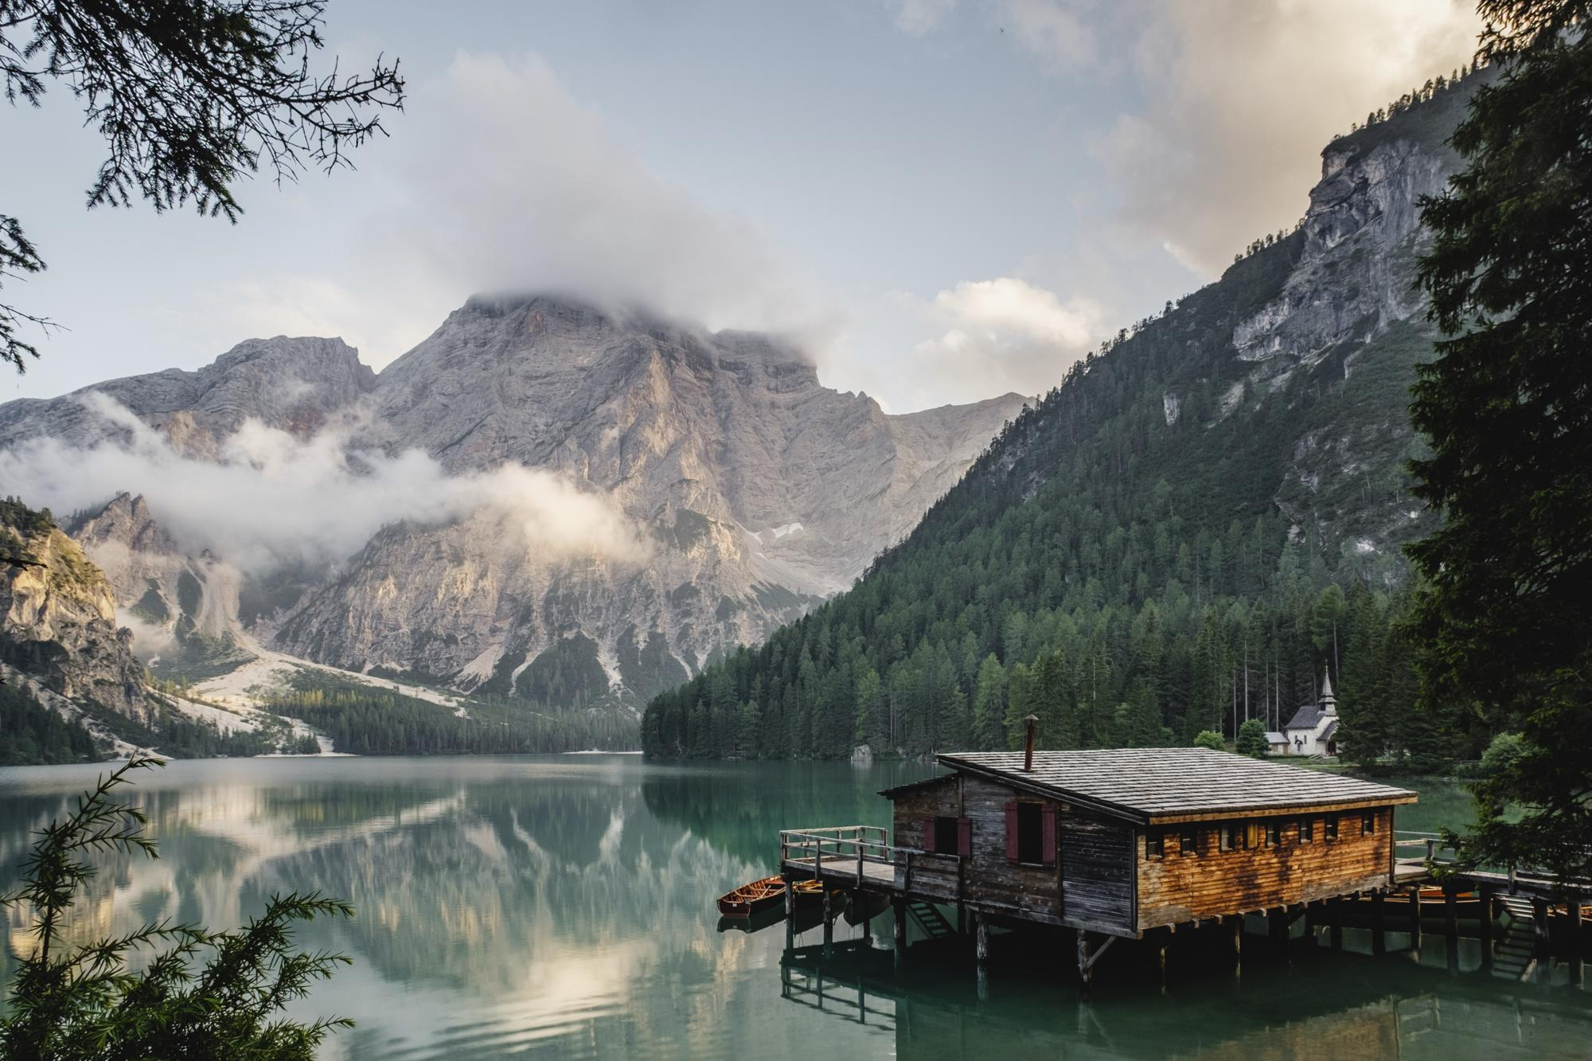
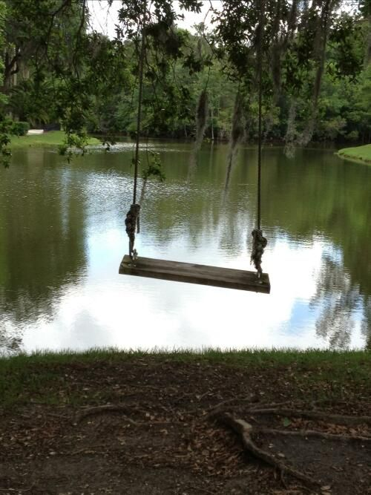

Inspired by image A or B (or both) write a DESCRIPTIVE paragraph using as many adjectives as possible and appeal to the readers FIVE SENSES
DO NOT write a short story – just one descriptive paragraph

