Are We Defined By What We Wear?
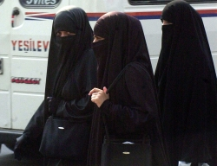
Does what we wear define who we are? Should we judge someone by what they are wearing? Do we wear things so that people will judge us a certain way? Or is what we wear really an expression of our identity? Our clothes are really just like the rest of our possessions; we choose things we prefer. Often people will choose cars so that people judge them in a certain way. Sometimes people may wear clothes to stand out, show their true identity, their uniqueness. Some people, though, choose clothes that hide them, let them blend in so that they do not have to be judged by everyone else. There are women who wear a piece of clothing called a Burka which covers their whole body and often the reason they give for this is the they do not what men in public looking at them and they want to keep their identity for the religion and their husband.

What About Uniforms?
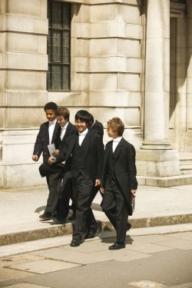
We wear a uniform so that we can be recognized by our school. This could have the effect of making us feel a sense of belonging when with others from our school but it can also isolate us from other schools as they wear different uniforms. Even the way we wear our uniform gives people a way to judge our identity; some people choose to take pride in their appearance and wear their uniform correctly and as neatly as possible where-as others choose to show that they a rebellious and do not like authority and so they were the uniform without pride and make it look a scruffy as possible. Others take no notice and just leave their uniform hey way they put it on in the morning because their uniform
does not cause them to feel isolated or accepted.

Goth/Emo
People that fit into this group are quite unique, that uniqueness is becoming less and less though as this type of look of ideology is growing. People in this group dress in dark clothes and always look forlorn. It shows that they might not be so self confident or that they might be against the whole idea of authority or society's conservative nature. People that are Goth or Emo are very defined by what they wear and you can tell what group they fit into just by looking at them. This is a unique case but supports the idea that what you wear defines who you are.

In Summary:
We wear clothes to give others an indication of our identity or to hide from them. Even when wearing the same thing such as a uniform we find ways to show our uniqueness to the world. Some people choose to wear clothes such as the Burka which hide them from society from fear of judgement and others wear next to nothing to show their proud of who they are. Whether it is a veil or a bikini what we wear gives some information about our identity and is many ways just a mirror of our personality and understanding of the world.

